Project Analysis & Design
Problem Statement, Objectives, Needs Assessment, Feasibility, Scope, Testing & Validation

Project Title: Analysis of the Impact of Crises on Global Maritime Shipping

1. Problem Statement
1.1 Background
Global maritime shipping plays a major role in international trade and the movement of goods between countries. Ships rely on important maritime routes and strategic chokepoints to transport cargo efficiently. However, global crises and unexpected disruptions can affect vessel traffic, interrupt shipping activities, and change the movement of ships across different maritime corridors.
Events such as geopolitical conflicts, security threats, and other major disruptions may lead to a decline in vessel traffic in affected areas. They may also cause changes in traffic patterns across alternative routes and influence the time required for shipping activity to recover.
Understanding these changes is important for shipping and logistics decision-makers because it helps them evaluate the vulnerability of maritime routes and understand how major disruptions affect global shipping activity.

1.2 Problem Description
The main problem addressed by this project is the difficulty of understanding and evaluating how major crises affect global maritime shipping activity across different maritime chokepoints and routes.
Without a structured analysis of historical vessel-traffic data, decision-makers may face challenges in identifying:
- The magnitude of vessel-traffic declines during major crises.
- Which maritime chokepoints and routes are most affected by disruptions.
- Whether vessel traffic changes across other corridors during a crisis.
- How long vessel traffic takes to recover after a disruption.
- Differences in shipping activity between normal periods and crisis-affected periods.
The project aims to address these challenges by collecting, preparing, storing, analyzing, and visualizing maritime shipping data using SQL Server, Python, and Power BI.

1.3 Problem Statement
The project addresses the need for a data-driven analytical solution that examines the impact of major crises on global maritime shipping. It focuses on analyzing changes in vessel traffic across selected maritime chokepoints, measuring traffic declines, identifying possible shifts in traffic across other corridors, and evaluating recovery patterns after disruptions.
The proposed solution will use historical maritime data from the IMF PortWatch platform, subject to the availability and suitability of the provided datasets. The data will be processed through a SQL Server Data Warehouse, analyzed using Python, and presented through an interactive Power BI dashboard.
The objective is to transform raw maritime data into meaningful insights that support a better understanding of the relationship between major crises and changes in global shipping activity.
---

2. Project Objectives (SMART Objectives)
The project objectives are designed according to the SMART framework:
- Specific: Clearly define what the project aims to achieve.
- Measurable: Use measurable indicators to evaluate the results.
- Achievable: Ensure that objectives can be completed using the available data, tools, and team capabilities.
- Relevant: Ensure that the objectives directly address the project's main problem.
- Time-bound: Complete the objectives within the approved project schedule.

2.1 Main Objective
To develop a data-driven analytical solution that evaluates the impact of major crises on global maritime shipping by analyzing vessel-traffic patterns across selected maritime chokepoints, identifying traffic declines and possible changes across other corridors, and examining recovery patterns using SQL Server, Python, and Power BI.
2.2 Specific Objectives
- Collect and organize maritime shipping data:
Obtain and organize the available historical maritime datasets from the IMF PortWatch platform to establish a reliable source for the project analysis.
- Build a structured Data Warehouse:
Design and implement a SQL Server Data Warehouse using Bronze, Silver, and Gold layers to store raw data, process cleaned data, and prepare analytical data for reporting.
- Prepare and analyze the data:
Clean the data in the SQL Server Silver layer, and use Python to perform additional data quality checks (and any remaining cleaning when needed), feature engineering, exploratory data analysis, and statistical analysis to identify relevant patterns and changes in vessel traffic.
- Measure vessel-traffic declines:
Analyze changes in vessel traffic during selected crisis periods and measure the magnitude of declines compared with an appropriate historical baseline.
- Examine changes across maritime corridors:
Compare vessel-traffic patterns across selected chokepoints and identify possible changes or shifts in traffic across other corridors during disruption periods, where supported by the available data.
- Evaluate recovery patterns:
Estimate the time required for vessel traffic to return toward its normal or baseline level after a disruption, using a clearly defined recovery measurement method.
- Develop an interactive Power BI dashboard:
Create an interactive dashboard that presents the main findings through appropriate KPIs, charts, comparisons, and filters.
- Validate the analytical results:
Verify data quality, transformation accuracy, and consistency between SQL Server results, Python analysis, and Power BI visualizations.

2.3 Measurable Success Criteria
The project will be considered successful when:
- The available maritime datasets have been successfully imported and organized.
- The Data Warehouse layers have been implemented according to the agreed architecture.
- Data cleaning and transformation processes have been completed and validated.
- The analysis identifies measurable changes in vessel traffic during selected crisis periods.
- Traffic comparisons across selected maritime corridors are presented where the available data supports them.
- Recovery patterns are calculated using a documented and consistent method.
- The Power BI dashboard presents the main analytical findings clearly.
- The dashboard results are consistent with the corresponding validated SQL queries and analytical outputs.
Time Boundary: All objectives and deliverables will be completed within the project schedule and before the final project submission deadline.

3. Needs Assessment

3.1 Introduction
The Needs Assessment identifies the gap between the current situation and the desired analytical solution. It determines what stakeholders need to understand the impact of crises on global maritime shipping and what resources are required to provide reliable analytical insights.
The project focuses on transforming historical maritime shipping data into structured information that can help users understand vessel-traffic changes and evaluate the effects of major disruptions.
3.2 Current Situation
Maritime shipping activity may change significantly during major crises. However, raw historical datasets alone may not provide decision-makers with a clear and organized understanding of these changes.
The available data needs to be collected, cleaned, structured, analyzed, and presented in a meaningful format before it can support effective analysis.
Without an integrated analytical solution, users may find it difficult to:
- Compare vessel traffic before, during, and after a crisis.
- Identify the maritime chokepoints most affected by disruptions.
- Measure the magnitude of traffic declines.
- Examine possible changes in traffic across alternative corridors.
- Determine how long recovery takes after a disruption.
- View the main findings through a unified and interactive dashboard.
3.3 Desired Situation
The desired situation is to provide an integrated analytical solution that organizes historical maritime data and converts it into clear, reliable, and useful insights.
The proposed solution will:
- Store and organize maritime data in a structured SQL Server Data Warehouse.
- Improve data quality through cleaning and transformation processes.
- Analyze vessel-traffic trends and changes using Python.
- Compare traffic patterns across selected chokepoints and relevant time periods.
- Evaluate recovery patterns after selected disruptions.
- Present analytical results through an interactive Power BI dashboard.
- Allow users to explore the results using appropriate filters and visualizations.
3.4 Types of Needs
- Felt Needs
Felt needs are needs expressed or experienced by stakeholders who require information to understand a particular problem or make better decisions.
For this project, the main felt needs include:
  - Shipping and Logistics Managers need to understand how crises affect vessel traffic and important maritime routes.
  - Executive Managers need a summarized overview of the impact of major disruptions on global maritime shipping.
  - Decision-makers need to identify which selected chokepoints experience the most significant traffic changes.
  - Users need to understand whether traffic patterns change across other corridors during crisis periods.
  - Users need to evaluate how long vessel traffic takes to recover after a disruption.
  - Project stakeholders need an interactive dashboard that presents the findings in a clear and understandable way.
- Normative Needs
Normative needs are needs identified according to accepted professional practices, technical requirements, and standards that should be followed to ensure the quality and reliability of the solution.
For this project, normative needs include:
  - Applying appropriate data-quality practices during data collection, cleaning, and transformation.
  - Maintaining the original raw data to preserve data traceability.
  - Using a structured Data Warehouse architecture to organize data.
  - Defining appropriate relationships between fact and dimension tables in the analytical data model.
  - Ensuring consistency and accuracy in calculated indicators and analytical measures.
  - Applying appropriate data validation procedures.
  - Designing clear and understandable visualizations.
  - Providing accurate labels, titles, filters, and units in the dashboard.
  - Ensuring that the dashboard results are consistent with the underlying analytical data.

3.5 Stakeholder Analysis
Stakeholder analysis identifies the groups affected by the project, their level of interest, their influence, and their main expectations.
Stakeholder Group | Impact/Power | Core Interest and Project  Expectations
Shipping and Logistics  Managers | High Impact / High Influence | Understand vessel-traffic changes, identify affected maritime chokepoints, and evaluate recovery patterns after crises.
Executive Managers | High Impact / High Influence | Obtain a summarized view of the impact of major disruptions and use analytical insights to support strategic understanding and decisionmaking.
Project Team | High Impact/ Medium  Influence | Collect, clean, store, analyze, and visualize maritime shipping data using the selected technologies.
Academic Supervisor | Medium Impact/ High Influence | Ensure that the project follows the required academic standards, technical methodology, documentation, and project objectives.
3.6 Required Resources
To address the identified needs, the project requires:
- Historical maritime shipping datasets from the IMF PortWatch platform.
- SQL Server for data storage and Data Warehouse implementation.
- Python for additional data quality checks, feature engineering, exploratory data analysis, and analytical calculations.
- Power BI for dashboard development and data visualization.
- Appropriate computing resources and software environments.
- A clearly defined project methodology and coordination between team members.

4. Feasibility Study
4.1 Introduction
The Feasibility Study evaluates whether the proposed project can be implemented successfully within the available technical, operational, and economic constraints.
It examines the availability of suitable technologies, the ability of the team to implement the proposed solution, the suitability of the solution for its intended users, and the expected costs associated with development and operation.
4.2 Technical Feasibility
Technical feasibility evaluates whether the required technologies, data sources, and technical capabilities are available to implement the project.
The project uses established tools and technologies for data engineering, analysis, and visualization.
Required Technologies:
Technology | Purpose
SQL Server | Store, Organize, and manage the Data Warehouse
SQL Server Management | Manage the SQL Server environment and execute
Studio (SSMS) | SQL queries
Python | Perform additional data quality checks, feature engineering, exploratory  Data analysis, and analytical calculations
Power BI | Develop interactive dashboards and visualize  Analytical results
IMF PortWatch Data | Provide historical maritime shipping data for  analysis
Technical Feasibility Considerations:
- The project uses established technologies suitable for data analytics and business intelligence.
- SQL Server supports structured data storage and the implementation of Bronze, Silver, and Gold Data Warehouse layers.
- Python provides libraries and tools for data processing, analysis, and visualization.
- Power BI supports interactive reporting and dashboard development.
- The IMF PortWatch platform provides a potential source of maritime shipping data relevant to the project.
Technical Constraints and Risks:
- The actual structure and completeness of the available CSV files must be examined before finalizing the database design.
- Some required indicators may not be directly available and may require calculations.
- The availability of historical data may differ between maritime chokepoints.
- Data quality issues, missing values, duplicate records, or inconsistent formats may affect the analysis.
- The project team must ensure that the selected tools can process the available data efficiently.
Technical Feasibility Conclusion:
The project is technically feasible because the selected tools are appropriate for data warehousing, data analysis, and visualization. Final implementation details will depend on examining the actual PortWatch datasets and confirming that the required analytical fields are available.
4.3 Operational Feasibility
Operational feasibility evaluates whether the proposed solution can be used effectively by its intended users and whether the project team can operate and maintain the analytical workflow.
The proposed solution is designed to provide users with a clear and accessible way to explore the impact of crises on global maritime shipping.
Operational Requirements:
- The dashboard should present the most important indicators in a clear and understandable format.
- Users should be able to filter results by available dimensions, such as time period, crisis event, or maritime chokepoint, depending on the dataset.
- Visualizations should make it easy to compare vessel-traffic patterns across different periods.
- The dashboard should provide clear information about traffic declines and recovery patterns.
- The project team should be able to repeat the data preparation and loading processes when updated datasets become available.
- The analytical workflow should be documented so that team members can understand and maintain it.
Operational Constraints:
- Users may have different levels of technical knowledge.
- Dashboard usability depends on clear visual design and appropriate explanations of the analytical indicators.
- The accuracy of the results depends on the quality and consistency of the source data.
- The team must coordinate the SQL Server, Python, and Power BI components to ensure a consistent workflow.
Operational Feasibility Conclusion:
The project is operationally feasible because it provides an organized analytical workflow and an interactive dashboard designed to present the findings in an understandable way. Its practical effectiveness will depend on the clarity of the dashboard, the quality of the data, and the successful integration of the project components.
4.4 Economic Feasibility
Economic feasibility evaluates the expected costs required to develop and operate the project compared with the resources available to the project team.
The project is primarily an academic data analytics project that uses existing software tools and publicly accessible maritime data, subject to their applicable access and usage conditions.
Potential Costs:
- Computing devices and internet access.
- Software installation, maintenance, or licensing if paid editions or additional services are required.
- Data storage and backup if additional storage services are needed.
- Any additional infrastructure or hosting services required for sharing or maintaining the dashboard.
Potential Cost-Saving Factors:
- Using available or free software editions where suitable.
- Using Python and its available data-analysis libraries.
- Using the available SQL Server environment.
- Using accessible historical data from the IMF PortWatch platform, subject to its terms and conditions.
- Developing the dashboard using the available Power BI edition and sharing options. Economic Feasibility Conclusion:
The project is expected to have manageable development costs because it can use existing tools and available data resources. However, the final cost depends on the software editions, infrastructure, storage, and dashboard-sharing requirements selected by the team.
No specific financial savings or return on investment are claimed because the project focuses on analytical evaluation rather than implementing or operating a real shipping service.

4.5 Overall Feasibility Conclusion
Based on the technical, operational, and economic considerations, the project is considered feasible within an academic project environment.
The selected technologies provide the necessary capabilities for data storage, processing, analysis, and visualization. The main conditions for successful implementation are the availability of suitable maritime datasets, proper data validation, effective coordination between team members, and completion of the work within the approved project schedule.
---

5. Project Scope and Constraints

5.1 Project Scope
The project focuses on analyzing the impact of major crises on global maritime shipping by examining changes in vessel traffic across selected maritime chokepoints and corridors.
It aims to transform historical maritime data into useful analytical insights through a structured Data Warehouse, Python-based analysis, and an interactive Power BI dashboard.
The project scope is divided into two main categories: In-Scope and Out-of-Scope activities.

5.2 In-Scope Activities
The following activities are included in the project:
5.2.1 Data Collection ○ Obtain the available maritime shipping datasets from the IMF PortWatch platform.
○ Review the structure, fields, and time coverage of the available CSV files. ○ Identify the datasets and variables relevant to the project objectives.

5.2.2 Data Warehousing
○ Design and implement a SQL Server Data Warehouse.
○ Organize the data using Bronze, Silver, and Gold layers.
○ Preserve raw data in the Bronze layer.
○ Clean and transform data in the Silver layer.
○ Prepare structured analytical data in the Gold layer.
○ Design appropriate fact and dimension tables based on the actual dataset structure.

5.2.3 Data Cleaning and Analysis
○ Clean the available datasets in the SQL Server Silver layer, and use Python for additional data quality checks and feature engineering.
○ Handle missing values, duplicates, and inconsistent data formats where necessary.
○ Perform exploratory data analysis.
○ Analyze vessel-traffic trends and changes over time.
○ Calculate relevant analytical indicators based on available data.

5.2.4 Crisis Impact Analysis
○ Examine vessel-traffic changes during selected crisis periods.
○ Measure the magnitude of traffic declines.
○ Compare traffic pattern

5.2.5 Dashboard Development
○ Develop an interactive Power BI dashboard.
○ Present relevant KPIs and analytical visualizations.
○ Provide appropriate filters and comparisons.
○ Display the main findings in a clear and understandable format.

5.2.6 Testing and Validation
○ Validate the quality and consistency of the data.
○ Verify SQL transformations and analytical calculations.
○ Compare Power BI results with the underlying SQL results.
○ Review the dashboard and analytical outputs to ensure that they meet the project objectives.

5.3 Out-of-Scope Activities
- The following activities are excluded from the current project scope:
- Analysis of shipping prices, freight rates, or transportation costs.
- Analysis of tariffs, customs duties, or financial charges.
- Financial performance evaluation of individual shipping companies.
- Forecasting future vessel traffic or predicting future crises.
- Real-time vessel tracking or live maritime monitoring.
- Controlling, managing, or rerouting actual vessels.
- Detailed port-level operational analysis.
- Implementing a real-world shipping management or logistics operating system.
- Developing a system for booking, managing, or dispatching vessels.
These activities are excluded to maintain the project's focus on historical maritime shipping data and the analytical impact of crises on vessel traffic.

5.4 Project Constraints and Assumptions
Project Constraints:
- The project depends on the availability and quality of the provided maritime datasets.
- The analysis is limited to the variables and time periods available in the source data.
- The project must be completed within the approved academic project timeline.
- The implementation depends on the available hardware, software, and team resources.
- The final analytical indicators and database structure must be consistent with the actual dataset fields.
Project Assumptions:
- The IMF PortWatch datasets will provide relevant historical maritime shipping information.
- The available data will contain sufficient information to analyze vessel-traffic patterns across selected maritime chokepoints.
- Selected crisis periods can be identified using reliable event information and agreed project definitions.
- The team will have access to the required software and computing resources.
- The project will use historical data rather than real-time maritime tracking.
Scope Clarification:
The final list of maritime chokepoints, crisis events, analytical KPIs, and dashboard filters will be confirmed after reviewing the actual datasets and agreeing on the project requirements. Any analysis that cannot be supported by the available data will not be presented as a confirmed result.

6. Functional and non-functional requirements:
6.1 Functional Requirements (with MoSCoW priority)
ID | Requirement | Priority
FR1 | Load the PortWatch data into Bronze, clean it in Silver, and build the Gold model | Must
FR2 | Show traffic and estimated cargo volume by chokepoint over time | Must
FR3 | Compare each crisis with a pre-event baseline (% drop) | Must
FR4 | Calculate recovery time in days | Must
FR5 | Filters by chokepoint, ship type, date, and event, with drill-down | Must
FR6 | Show traffic changes on alternative routes | Should
FR7 | Rank chokepoints by vulnerability | Should
FR8 | Link disruption events to the affected chokepoints | Should
Won’t have: prices, costs, tariffs, forecasting, and port-level analysis.
6.2 Non-functional Requirements
ID | Area | Requirement
NFR1 | Performance | The dashboard responds quickly when filters change
NFR2 | Security | Only public data, no personal data, and we follow the PortWatch license and citation
NFR3 | Usability | A simple, clear layout that non-technical managers can read, with labeled charts
NFR4 | Reliability | Quality checks in each layer, and the dashboard numbers match the SQL results
Constraints: the cargo values are preliminary estimates, there is no price or cost data, we use a fixed snapshot of the data with the download date recorded, and we have 4 weeks.

7. Use Case Diagram
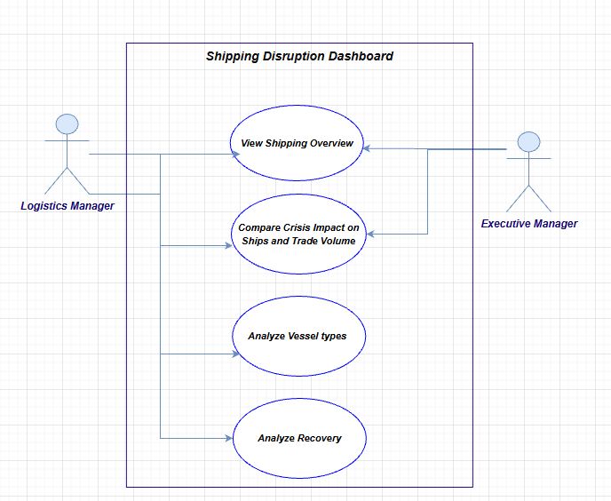

8. Use Case Descriptions

Use Case 1: View Shipping Overview
Use Case Name | View Shipping Overview
Actor(s) | Executive Manager, Logistics Manager
Description | Allows the user to view a high-level summary of global shipping activity, including the number of ships, the estimated trade volume, and the crises that have affected shipping.
Precondition | The data is loaded and the dashboard is open.
Main Flow | 1. The user opens the Executive Overview page.  2. The system displays the overall shipping summary (number of ships, trade volume, and crises) for all events.  3. The user optionally filters by a specific crisis.  4. The system updates the visuals to show the number of ships and trade volume for the selected crisis.
Alternative Flow | If no data is available for the selected filter, the system displays a "No data available" message and the user can choose a different option or reset the filter.
Postcondition | The user understands the overall shipping activity and which crises have affected shipping, including their effect on ship counts and trade volume.

Use Case 2: Compare Crisis Impact on Ships and Trade Volume
Use Case Name | Compare Crisis Impact on Ships and Trade Volume
Actor(s) | Executive Manager, Logistics Manager
Description | Allows the user to measure how much a crisis reduced the number of ships and the trade volume compared to normal levels, and whether the crisis had a real impact.
Precondition | The data is loaded and the dashboard is open.
Main Flow | 1. The user opens the Crisis Impact page.  2. The system displays the impact of all crises on ship counts and trade volume.  3. The user selects a specific crisis using the filter.  4. The system shows the change in the number of ships and trade volume before, during, and after the selected crisis compared to normal levels.  5. The system ranks the chokepoints from the most to the least affected.
Alternative Flow | If no data is available for the selected crisis, the system displays a "No data available" message and the user can choose a different option or reset the filter.
Postcondition | The user knows how much each crisis affected the number of ships and the trade volume, and which chokepoints were affected the most.

Use Case 3: Analyze Vessel Types
Use Case Name | Analyze Vessel Types
Actor(s) | Logistics Manager
Description | Allows the user to see which vessel types (container, tanker, dry bulk, general cargo, and RoRo) were most affected by a crisis.
Precondition | The data is loaded and the dashboard is open.
Main Flow | 1. The user opens the Vessel Type page.  2. The system displays the number of ships and trade volume for each vessel type.  3. The user selects a specific crisis or vessel type using the filter.  4. The system shows how the selected crisis affected each vessel type.
Alternative Flow | If no data is available for the selected filter, the system displays a "No data available" message and the user can choose a different option or reset the filter.
Postcondition | The user knows which vessel types were affected the most by crises.

Use Case 4: Analyze Recovery
Use Case Name | Analyze Recovery
Actor(s) | Logistics Manager
Description | Allows the user to see how long it took for shipping traffic to return to its normal level after a crisis.
Precondition | The data is loaded and the dashboard is open.
Main Flow | 1. The user opens the Recovery page.  2. The system displays the recovery time for each completed crisis.  3. The user selects a specific crisis using the filter.  4. The system shows the recovery timeline and the number of days it took for shipping to return to normal.
Alternative Flow | If the selected crisis is still ongoing, the system marks it as "Ongoing" and shows its current traffic level compared to normal instead of a recovery time.  If no data is available, the system displays a "No data available" message.
Postcondition | The user knows how many days each completed crisis took to recover and the current status of ongoing crises compared to normal levels.

9. Data Architecture (Medallion)

Bronze: raw layer
- Exact copy of the downloaded PortWatch files (daily chokepoint transits, chokepoint list, and disruption events).
- No modification. Each file is loaded into Bronze tables in SQL Server with a load_date so any result can be traced to a specific data version.
- Files are loaded into Bronze with BULK INSERT.
- PortWatch data is revised weekly, so keeping every snapshot protects reproducibility.

Silver: cleaned layer
Silver and Gold are built and run with dbt.
Transformations applied:
- Enforce data types (dates, integers, floats).
- Standardize column names (for example, chokepoint fields must not reuse port_* names).
- Remove duplicates on the natural key (date, chokepoint, vessel type).
- Decide and document the treatment of missing days: a zero-activity row versus an absent row. The choice affects averages.
- Flag outliers and implausible values (negative volumes, vessel counts far outside history). AIS data is noisy, especially in conflict zones where transponders may be switched off.
- Unpivot the wide vessel-type columns (container, dry bulk, general cargo, RoRo, tanker) into one row per vessel type.

Gold: analytical layer (star schema)
Matches the ER diagram, with two additions needed to study crises: an event dimension and a bridge table.
Dimensions
- dim_date: date_id (YYYYMMDD), full_date, year, quarter, month, iso_week, week_start_date, day, day_of_week, is_weekend
- dim_chokepoint: chokepoint_id, chokepoint_code, chokepoint_name, fullname, country, ISO3, continent, lat, lon
- dim_vessel_type: vessel_type_id, type_code, type_name, is_cargo
- dim_event: event_id, event_name, event_type, start_date, end_date, description
- bridge_event_chokepoint: event_id, chokepoint_id (many-to-many)
Facts
- fact_daily_transit: (date_id, chokepoint_id, vessel_type_id) → vessel_count, capacity
- fact_daily_summary: (date_id, chokepoint_id) → capacity_total, capacity_cargo, source_object_id
Consistency check: The vessel counts in fact_daily_transit, summed for the same date and chokepoint, must equal n_cargo and n_total in Bronze. Capacity totals are not checked this way, because they do not equal the sum of the per-type capacities in all rows. This check runs after every load.

Analytical views on Gold
- vw_weekly_chokepoint: weekly aggregation (daily data has many zero days, so weekly smoothing is used).
- vw_baseline_deviation: current week versus the average of the same ISO week in a reference period, per chokepoint and vessel type.
- vw_event_window: weeks relative to event start (t = -12 … +26) for event-study charts.

10. Component Diagram
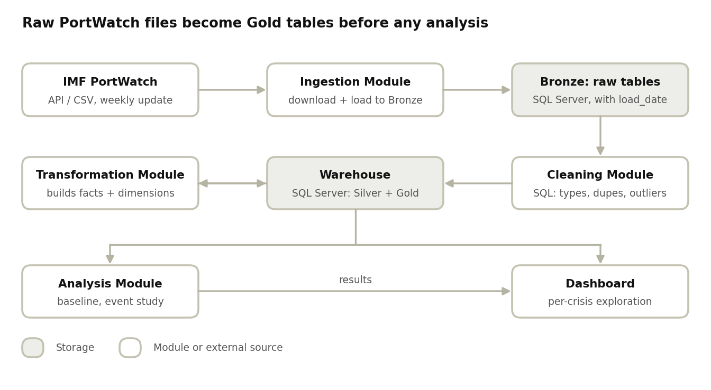
component diagram · 8 components
Read the top row first, then down: shaded boxes hold data, outlined boxes do the work.
Component | Responsibility | Inputs → Outputs
Ingestion Module | Download datasets, store raw snapshot with load_date | API/CSV → Bronze tables
Cleaning and Validation | Types, duplicates, missing days, outlier flags | Bronze → Silver tables
Transformation Module | Build dimensions, facts, views | Silver → Gold
Analysis Module | Baselines, event study, difference-in-differences | Gold → result tables and charts
Dashboard | Interactive exploration per crisis | Gold + results → user
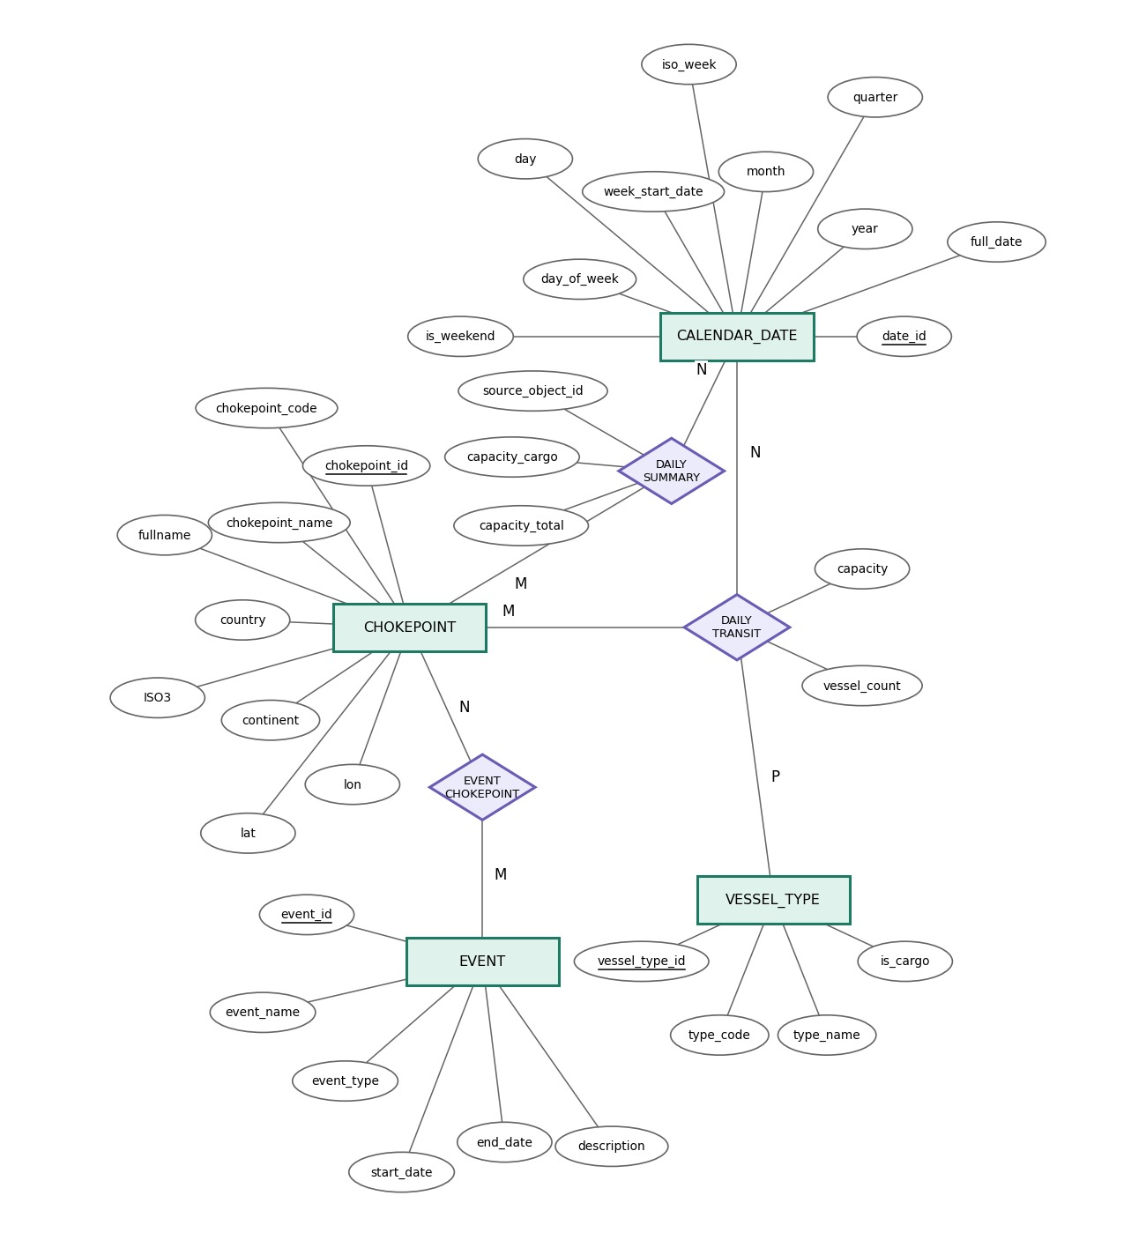

11. Logical Schema
Daily Chokepoints Data (28 chokepoints, 2019-01-01 to 2026-10-25)

11.1 Overview
The source file Daily_Chokepoints_Data.csv has 79,940 rows. Each row is one chokepoint on one day, with counts and capacities repeated for five vessel types. The schema below normalizes it into 4 dimension tables, 1 bridge table and 2 fact tables (star schema).

Design decisions
- portid and portname are 1:1, so they are moved to dim_chokepoint.
- year, month and day are derived from date, so they are moved to dim_date.
- The repeated per-type columns (container, dry_bulk, general_cargo, roro, tanker) become rows keyed by dim_vessel_type.
- n_cargo and n_total are derived (match the source on 100% of rows), so they are not stored.
- capacity_cargo and capacity cannot be derived: they equal the sum of the per-type capacities in only about 24% and 54% of rows. They are stored as reported in fact_daily_summary.

11.2 Relations

dim_chokepoint
Attribute | Data type | Key | Notes
chokepoint_id | SMALLINT | PK | Surrogate key
chokepoint_code | VARCHAR(20) | UK | Source portid, e.g. chokepoint1
chokepoint_name | VARCHAR(60) | UK | Source portname, e.g. Suez Canal
fullname | VARCHAR(100) |  | Source fullname
country | VARCHAR(60) |  | Source country
ISO3 | CHAR(3) |  | Source ISO3
continent | VARCHAR(30) |  | Source continent
lat | DECIMAL(9,6) |  | Source lat
lon | DECIMAL(9,6) |  | Source lon

dim_date
Attribute | Data type | Key | Notes
date_id | INT | PK | Format yyyymmdd, e.g. 20230520
full_date | DATE | UK | Source date
year | SMALLINT |  | 1..9999
quarter | SMALLINT |  | 1..4
month | SMALLINT |  | 1..12
iso_week | SMALLINT |  | 1..53
week_start_date | DATE |  | First day of the ISO week
day | SMALLINT |  | 1..31
day_of_week | SMALLINT |  | 1..7
is_weekend | BOOLEAN |  | TRUE for weekend days

dim_vessel_type
Attribute | Data type | Key | Notes
vessel_type_id | SMALLINT | PK | Surrogate key
type_code | VARCHAR(20) | UK | container, dry_bulk, general_cargo, roro, tanker
type_name | VARCHAR(40) |  | Display name
is_cargo | BOOLEAN |  | TRUE for all types except tanker

dim_event
Attribute | Data type | Key | Notes
event_id | INT | PK | Surrogate key
event_name | VARCHAR(200) |  | Source eventname
event_type | VARCHAR(50) |  | Source eventtype
start_date | DATE |  | Source fromdate
end_date | DATE |  | Source todate
description | VARCHAR(500) |  | Event description

fact_daily_transit (fact, one row per chokepoint, date and vessel type)
Attribute | Data type | Key | Notes
chokepoint_id | SMALLINT | PK, FK | References dim_chokepoint
date_id | INT | PK, FK | References dim_date
vessel_type_id | SMALLINT | PK, FK | References dim_vessel_type
vessel_count | INT |  | From n_<type>, >= 0
capacity | BIGINT |  | From capacity_<type>, >= 0

fact_daily_summary (fact, one row per chokepoint and date)
Attribute | Data type | Key | Notes
chokepoint_id | SMALLINT | PK, FK | References dim_chokepoint
date_id | INT | PK, FK | References dim_date
source_object_id | INT | UK | ObjectId from the CSV
capacity_cargo | BIGINT |  | Stored as reported
capacity_total | BIGINT |  | Source capacity, stored as reported

bridge_event_chokepoint (bridge, one row per event and chokepoint)
Attribute | Data type | Key | Notes
event_id | INT | PK, FK | References dim_event
chokepoint_id | SMALLINT | PK, FK | References dim_chokepoint

11.3 Relationships and constraints
- dim_chokepoint 1 : N fact_daily_transit (chokepoint_id)
- dim_date 1 : N fact_daily_transit (date_id)
- dim_vessel_type 1 : N fact_daily_transit (vessel_type_id)
- dim_chokepoint 1 : N fact_daily_summary (chokepoint_id)
- dim_date 1 : N fact_daily_summary (date_id)
- dim_event 1 : N bridge_event_chokepoint (event_id)
- dim_chokepoint 1 : N bridge_event_chokepoint (chokepoint_id)
- No null values exist in the source, so every attribute is NOT NULL.
- All counts and capacities must be >= 0.

11.4 Derived values
- n_cargo = n_container + n_dry_bulk + n_general_cargo + n_roro (sum of fact_daily_transit.vessel_count where is_cargo = TRUE)
- n_total = n_cargo + n_tanker (sum of vessel_count over all types)

11.5 Expected row counts
- dim_chokepoint: 28
- dim_vessel_type: 5
- fact_daily_summary: 79,940
- fact_daily_transit: 399,700 (79,940 x 5)
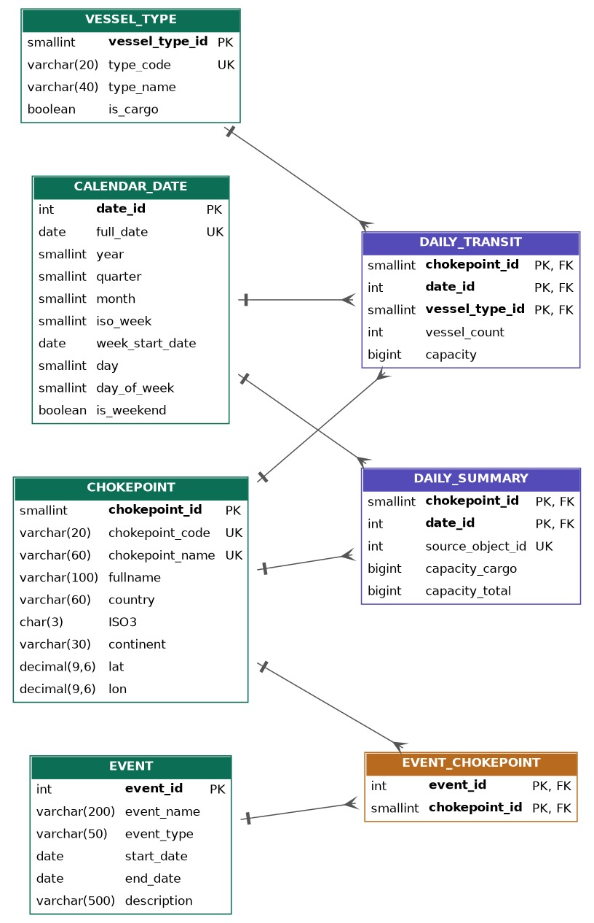
12. DFD (level 0):
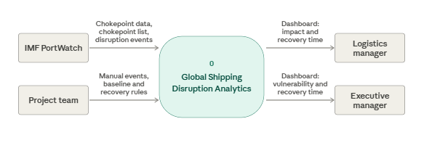
This diagram shows the whole project as one process. What IMF PortWatch and our project team provides. The project produces a dashboard that shows impact, recovery time, and vulnerability to the logistics manager and the executive manager
13. DFD (level 1):
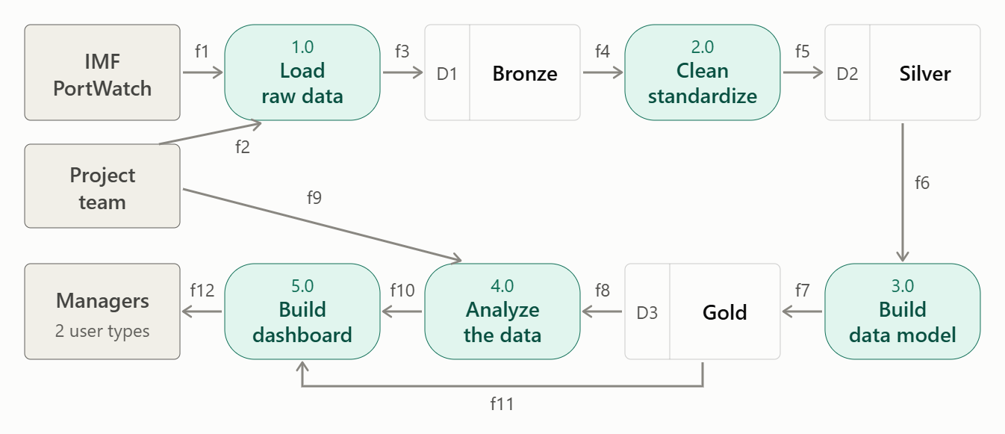
Data flow table
Tag | From → To | Data
f1 | PortWatch → 1.0 | Daily chokepoint data, chokepoint list, disruption events
f2 | Project team → 1.0 | Manual events table
f3 | 1.0 → D1 | Raw tables
f4 | D1 → 2.0 | Raw tables
f5 | 2.0 → D2 | Cleaned tables
f6 | D2 → 3.0 | Cleaned tables
f7 | 3.0 → D3 | Fact and dimension tables
f8 | D3 → 4.0 | Gold tables
f9 | Project team → 4.0 | Baseline and recovery rules
f10 | 4.0 → 5.0 | Business insights
f11 | D3 → 5.0 | Gold tables
f12 | 5.0 → Managers | Dashboard: impact, recovery time, vulnerability

This diagram opens the project into five processes and three data stores.
1) We download the PortWatch files and load the raw data into the Bronze store.
2) then we clean and standardize the data into the Silver store.
3) then we build the data model in the Gold store.
4) then we analyze the Gold data using the team’s baseline and recovery rules.
5) and finally, we build the dashboard from the Gold data and the insights, and deliver it to the two managers(Logistics manager and Executive manager).
14. Activity diagram:
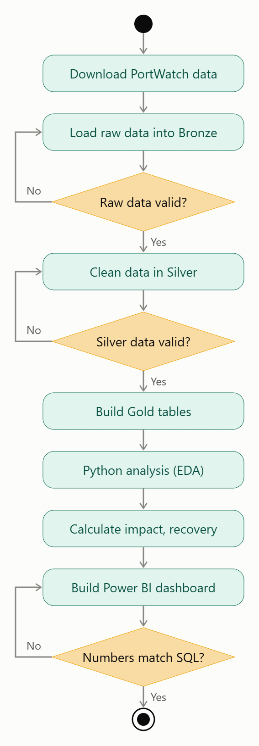
The workflow starts by downloading a fixed snapshot of the PortWatch data and loading it into Bronze. We then check whether the raw data is valid. If not, we go back and fix the load. Next, we clean the data in Silver and check again, going back to cleaning if the check fails. After that, we build the Gold tables, analyze the data in Python, and calculate the impact and recovery time for each event. Finally, we build the Power BI dashboard and check that its numbers match the SQL results. If they don’t, we fix the dashboard measures.

15. Sequence Diagram: Data Load and Validation
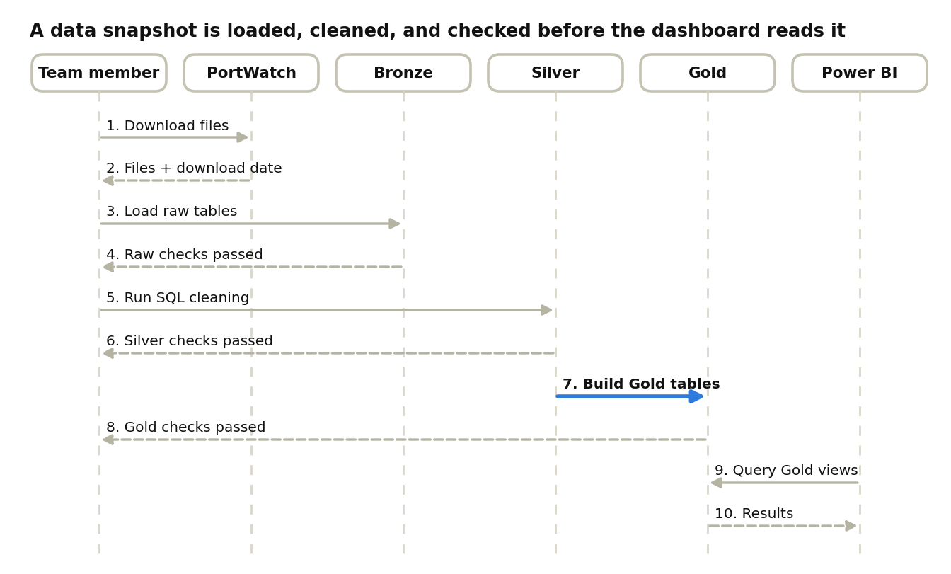
sequence diagram · data load and validation, 10 messages
Step 7 is the heart of the load; dashed arrows are replies.
Second scenario: analyst studies a crisis
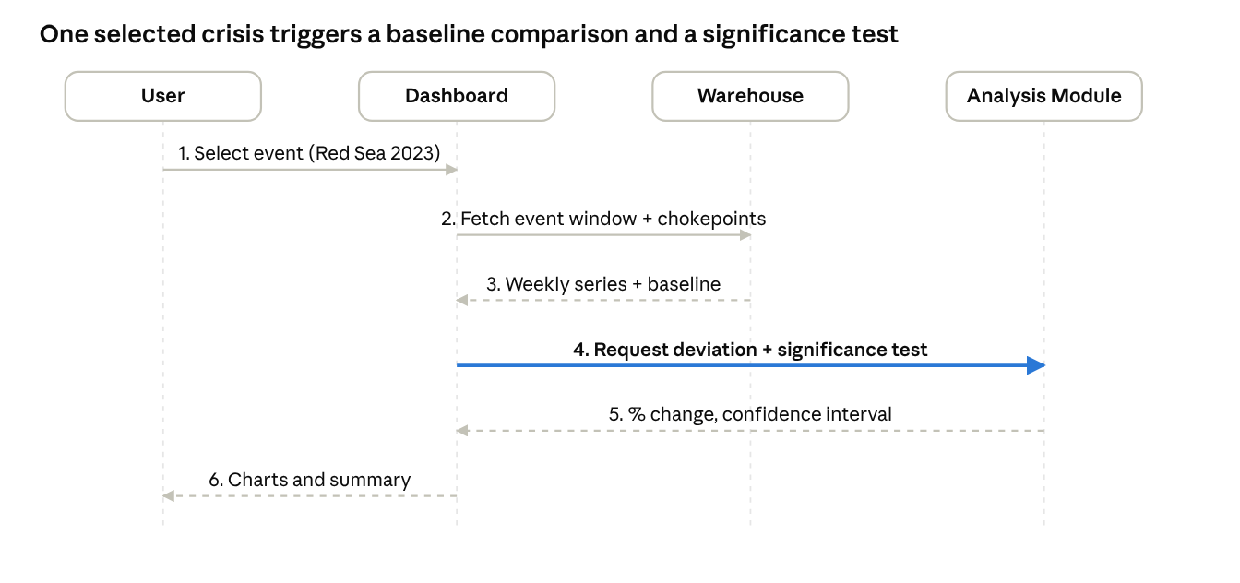
sequence diagram · analyst studies a crisis, 6 messages
The dashboard fetches data from the warehouse, then asks the analysis module to test it; dashed arrows are replies.

16. Wireframes

16.1 Executive Overview
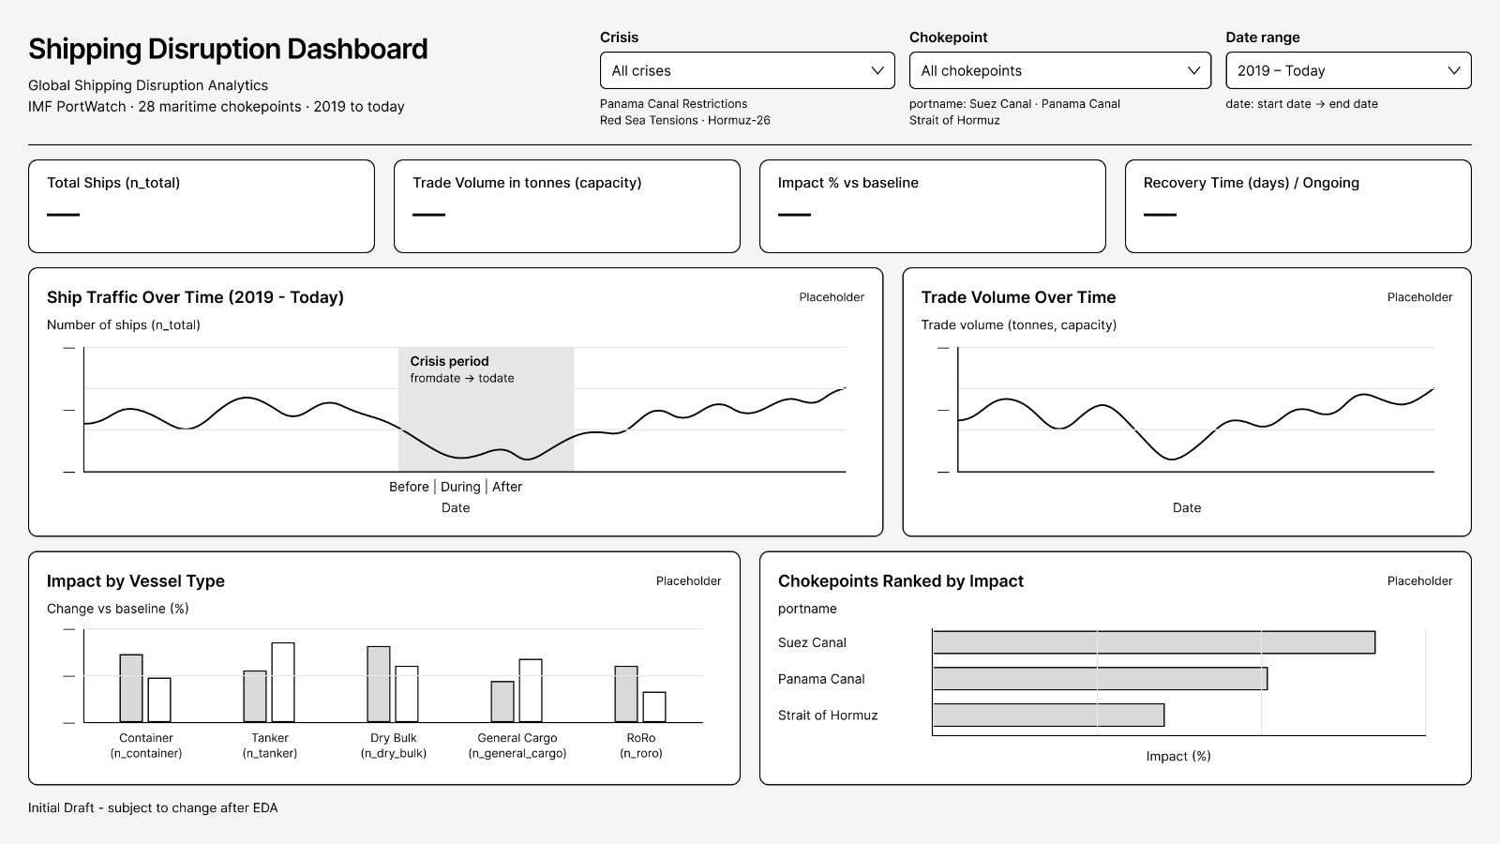

16.2 Analysis Pages Layout (Crisis Impact, Vessel Type, Recovery)
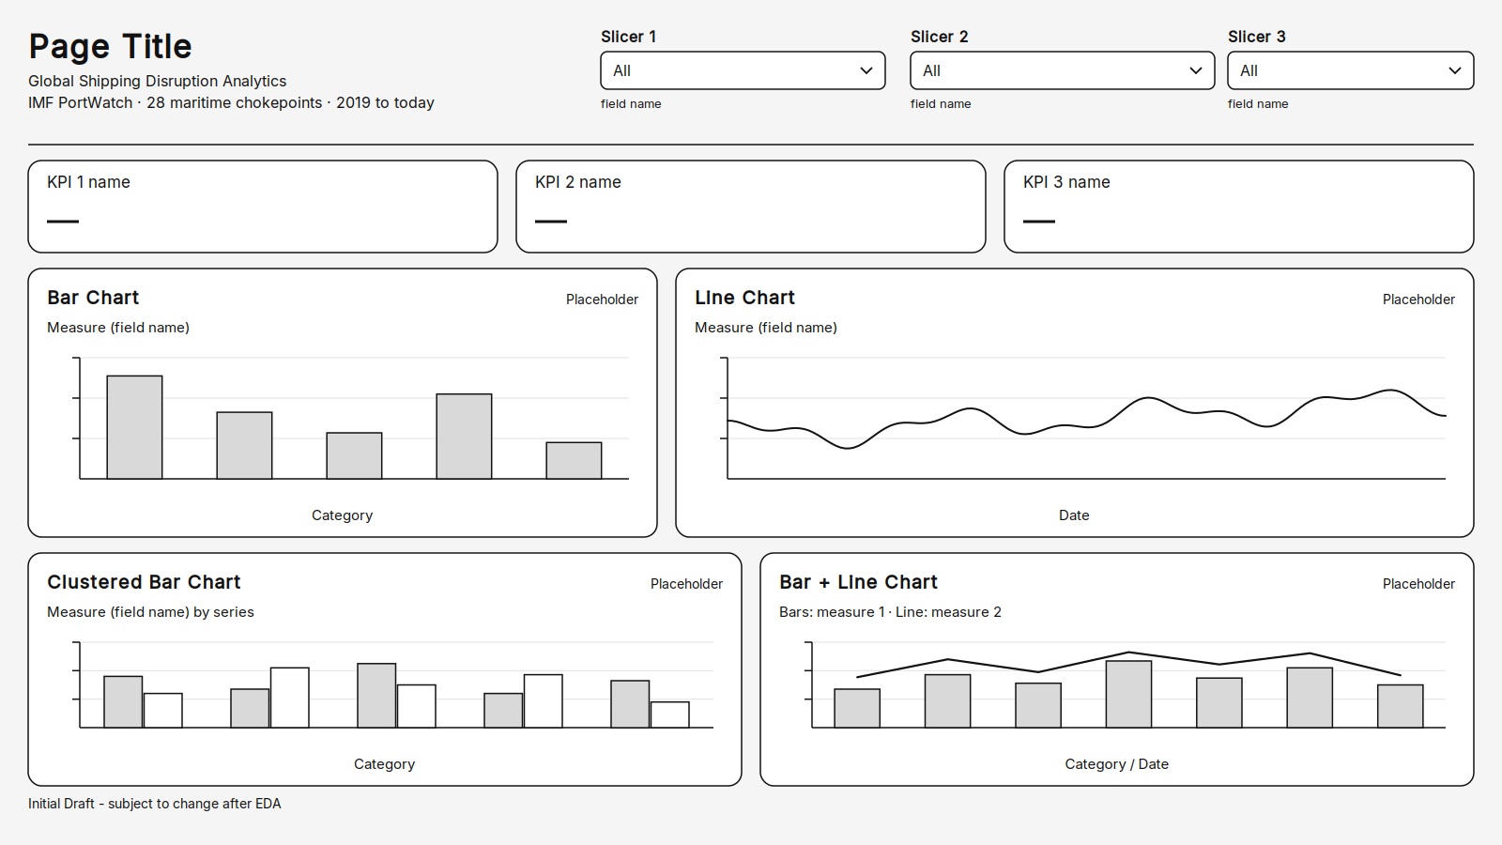

17. UI/UX Guidelines

17.1 Color Scheme
Color | Code | Usage
Dark navy blue (Navy) | #0B2545 | Header, titles, main lines
Medium blue (Ocean) | #1F6FB2 | Regular charts, slicers
Orange (Container) | #F28C28 | Important KPIs, buttons, highlights
Red | #D64545 | Crisis periods, drops in traffic (red always means crisis)
Green | #2E9E6B | Return to normal levels
Light gray | #F4F6F8 | Page background
Dark gray | #333F4B | Text and labels

17.2 Typography
Element | Size (pt)
Title | 24
Subtitle | 16
Text | 12

17.3 Layout
The header, slicers and KPI cards are always placed at the top of every page, in the same position.
Page order: Executive Overview, Crisis Impact, Vessel Type, Recovery.

17.4 Accessibility Considerations
- Good color contrast between text and background.
- Color is not the only way to show a crisis: it is marked with red and also with a shaded band and a label.
- Text is never smaller than 12 pt.
- Every chart has a title, and every axis has a name and unit.
- Key visuals have a short alt text in Power BI.

18. Technology Stack
Layer | Tool | Justification
Source | IMF PortWatch (ArcGIS API / CSV download) | Public, free, updated weekly on Tuesdays
Ingestion | Python 3 (requests, pandas) | Simple, scriptable, easy to schedule
Raw storage (Bronze) | SQL Server Bronze tables, timestamped by load date | Immutable copy of the source; enables reprocessing
Warehouse (Silver + Gold) | SQL Server | Standard SQL, supports star schema and constraints
Transformation | SQL scripts, orchestrated from Python | Transparent, reviewable by the whole team
Analysis | Python (pandas, statsmodels, scipy) | Baseline comparison, event study, difference-in-differences
Visualization | Power BI | Matches the UI/UX guidelines and wireframes
Version control | Git + GitHub | Team collaboration and history

19. Deployment Diagram
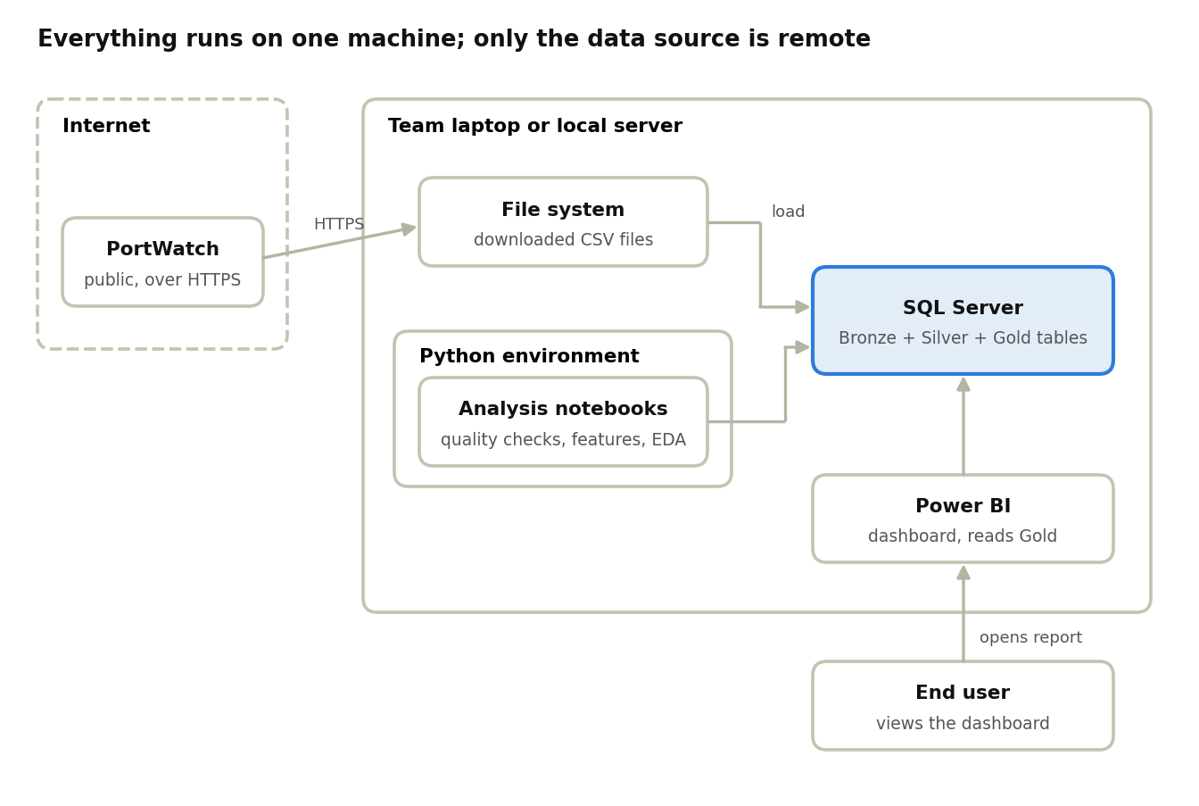
deployment diagram · one machine, one remote source
The dashed border marks the remote zone; the highlighted database is the hub that scripts, notebooks and the dashboard all use.
For the course project everything runs on one machine. A production variant would move the database to a managed service and containerize the pipeline with Docker, without changing the logical design.

